***GTEC 22043- Object Oriented Programming***

***Lab worksheet 2:***

***Numerical Data***

**CT/2021/039**

**Question 01:**

**Code:**

package Q_01;  
  
import java.lang.Math;  
import java.util.Scanner;  
  
public class Q_1 {  
 public static void main(String[] arg){  
 Scanner scanner = new Scanner(System.*in*);  
  
 System.*out*.print("Enter value for A: ");  
 double A = scanner.nextDouble();  
  
 System.*out*.print("Enter value for B: ");  
 double B = scanner.nextDouble();  
  
 System.*out*.print("Enter value for C: ");  
 double C = scanner.nextDouble();  
  
 double resultA;  
 resultA = Math.*sqrt*(Math.*pow*(B,2) + 4 * A * C);  
 System.*out*.print("square root of B^2 + 4AC: " + resultA);  
  
 System.*out*.print("\nEnter value for X: ");  
 double X = scanner.nextDouble();  
  
 System.*out*.print("Enter value for Y: ");  
 double Y = scanner.nextDouble();  
  
 double resultB;  
 resultB = Math.*sqrt*(X + 4 * Math.*pow*(Y,3));  
 System.*out*.print("\nSquare root of X + 4Y^3: " + resultB);  
  
 double resultC;  
 resultC = Math.*cbrt*(X*Y);  
 System.*out*.print("\nCube root of(X*Y): " + resultC);  
  
 System.*out*.print("\nEnter value for radius: ");  
 double radius = scanner.nextDouble();  
  
 double area=Math.*PI* * Math.*pow*(radius,2);  
 System.*out*.print("\nArea of a circle: "+area);  
  
 scanner.close();  
 }  
}

**Output:**

**a.)**

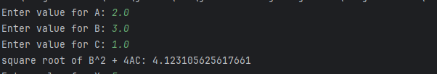

**b.) c.)**

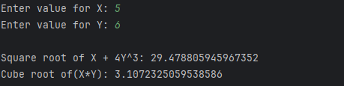

**d.)**

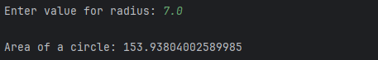

**Question 02:**

**Code:**

package Q_02;  
  
import java.util.Scanner;  
  
public class Q_2 {  
 public static void main(String[] args){  
 Scanner scanner = new Scanner(System.*in*);  
 System.*out*.print("Enter the length in centimeters: ");  
 double cm=scanner.nextDouble();  
  
 double inches = cm /2.54;  
 int feet = (int)(inches/12);  
 double remainingInches = inches % 12;  
  
 System.*out*.printf("%.2f cm is approximately %d feet and %.2f inches.%n" , cm,feet,remainingInches);  
  
 scanner.close();  
  
 }  
}

**Output:**

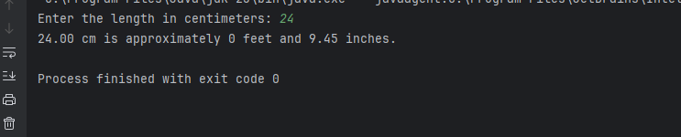

**Question 03:**

**Code:**

package Q_03;  
  
import java.util.Scanner;  
  
public class Q_3 {  
 public static void main(String[] args){  
 Scanner scanner = new Scanner(System.*in*);  
  
 System.*out*.print("Enter temperature in Celsius: ");  
 double celsius = scanner.nextDouble();  
  
 double fahrenheit = (1.8 * celsius) + 32;  
  
 System.*out*.printf("Temperature in Fahrenheit: %.2f°F%n", fahrenheit);  
  
 scanner.close();  
 }  
}

**Output**:

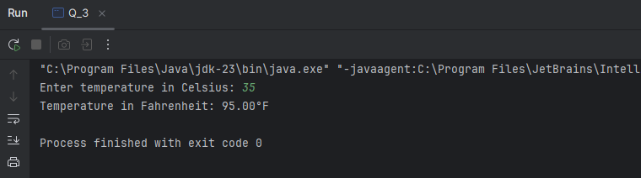

**Question 04:**

**Code:**

**package Q_04;  
  
import java.util.Scanner;  
  
public class Q_4 {** public static void main(String[] args){  
 Scanner scanner = new Scanner(System.*in*);  
  
 System.*out*.print("Enter the your weight in pounds: ");  
 double bodyWeight = scanner.nextDouble();  
  
 double caloriesNedeed = bodyWeight * 19;  
  
 System.*out*.printf("You need approximately %.2f calories per day.%n",caloriesNedeed);  
  
 scanner.close();  
  
 }  
}

**Output**:

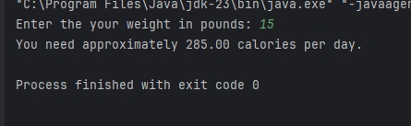

**Question 05:**

**Code:**

package Q_05;  
  
import java.util.Scanner;  
  
public class Q_5 {  
 public static void main(String[] args){  
 Scanner scanner = new Scanner(System.*in*);  
 System.*out*.print("Enter the temperature in degrees Fahrenheit: ");  
 double Fahrenheit = scanner.nextDouble();  
  
 double Celsius = (5.0/9.0)*(Fahrenheit - 32);  
  
 System.*out*.printf("Temperature in celsius: %.2f°C%n",Celsius);  
 scanner.close();  
 }  
}

**Output:**

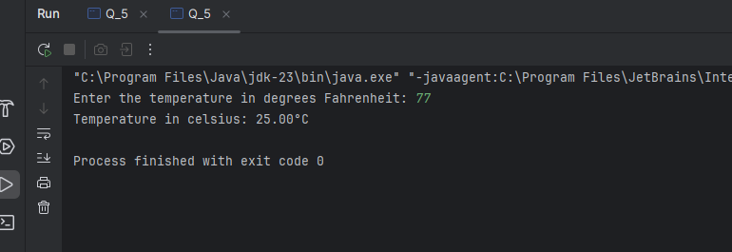

**Question 06:**

**Code:**

package Q_06;  
  
import java.time.Year;  
import java.util.Scanner;  
  
public class Q_6 {  
 public static void main(String[] args){  
 Scanner scanner= new Scanner(System.*in*);  
  
 int currentYear = Year.*now*().getValue();  
 System.*out*.print("Enter your born year: ");  
 int birthYear = scanner.nextInt();  
  
 int age = currentYear - birthYear;  
  
 System.*out*.printf("You were born in %d and will be (are) %d this year.%n ",birthYear,age);  
 }  
}

**Output:**

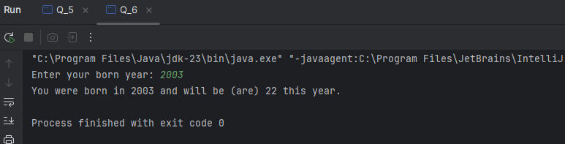

**Question 07:**

**Code:**

package Q_07;  
  
import java.util.Scanner;  
  
public class Q_7 {  
 public static void main(String[] args){  
  
 Scanner scanner = new Scanner(System.*in*);  
  
 System.*out*.printf("Enter your weight in kg: ");  
 double weight = scanner.nextDouble();  
  
 System.*out*.printf("Enter your height in cm: ");  
 double height = scanner.nextDouble();  
  
 double BMI = weight/ Math.*pow*(height / 100.0,2);  
  
 System.*out*.printf("Your BMI is: %.2f%n", BMI);  
  
 scanner.close();  
  
 }  
}

**Output:**

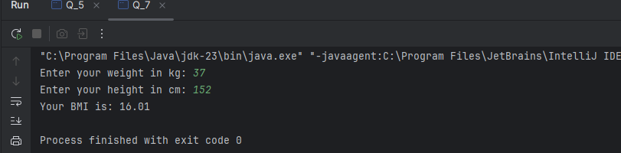

**Question 08:**

**Code:**

package Q_08;  
  
import java.util.Scanner;  
  
public class Q_8 {  
 public static void main(String[] args){  
 Scanner scanner = new Scanner(System.*in*);  
  
 System.*out*.print("Enter the value of radius: ");  
 double radius = scanner.nextDouble();  
  
 double Volume = (4.0/3.0)*(Math.*PI* * Math.*pow*(radius,3));  
  
 System.*out*.printf("The volume of the sphere is: %.2f%n",Volume);  
  
 scanner.close();  
 }  
}

**Output:**

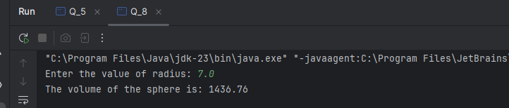

**Question 09:**

**Code:**

package Q_09;  
  
import java.util.Scanner;  
  
public class Q_9 {  
 public static void main(String[] args){  
 Scanner scanner = new Scanner(System.*in*);  
  
 System.*out*.print("Enter the investment (P): ");  
 double P = scanner.nextDouble();  
  
 System.*out*.print("Enter the annual interest rate (R in %): ");  
 double R = scanner.nextDouble();  
  
 System.*out*.print("Enter the number of years (N): ");  
 int N = scanner.nextInt();  
  
 double finalAmount = P* Math.*pow*(1 + (R/100),N);  
  
 System.*out*.printf("The amount of money earned after %d years is: %.2f%n ",N,finalAmount);  
  
 scanner.close();  
  
 }  
}

**Output:**

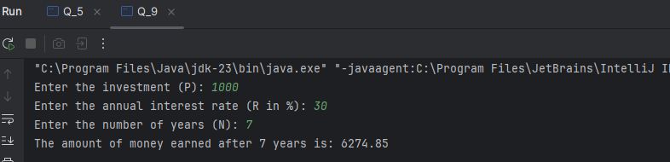

**Question 10:**

**Code:**

package Q_10;  
  
import java.util.Scanner;  
  
public class Q_10 {  
 public static void main(String[] args) {  
 Scanner scanner = new Scanner(System.*in*);  
  
 final int MONTHS_IN_YEAR = 12;  
  
 System.*out*.print("Enter the loan amount: ");  
 double loanAmount = scanner.nextDouble();  
  
 System.*out*.print("Enter the annual interest rate(in %): ");  
 double annualInterestRate = scanner.nextDouble();  
  
 System.*out*.print("Enter the loan period(years): ");  
 int loanPeriod = scanner.nextInt();  
  
 double monthlyInterestRate = annualInterestRate /100.0 / MONTHS_IN_YEAR;  
  
 int numberOfPayments = loanPeriod * MONTHS_IN_YEAR;  
  
 double monthlyPayment = (loanAmount * monthlyInterestRate) / (1- Math.*pow*(1/(1 + monthlyInterestRate),numberOfPayments));  
  
 double totalPayment = monthlyPayment * numberOfPayments;  
  
 System.*out*.printf("Monthly Payment: %.2f%n",monthlyPayment);  
 System.*out*.printf("Total Payment: %.2f%n",totalPayment);  
  
 scanner.close();  
  
  
 }  
}

**Output:**

